**These are the notes referred to on the following official copy**

Title Number AGL514205

The electronic official copy of the document follows this message. This copy may not be the same size as the original.

Please note that this is the only official copy we will issue. We will not issue a paper official copy.

## I

LAND REGISTRY

I

LAND REGISTRATION ACT 2002

I I I

|  |  |  |
| --- | --- | --- |
|  |  |  |
| LANDLORD'S TITLE NUMBER | | MX334541 |
| **THER TITLE NUMBER(S)** | | IAGL60759 |

**PRESCRIBED CLAUSES**

|  |  |
| --- | --- |
| **ILR1. Date of lease** | *28 August 2020* |
| **LR2. Title numbers)** | **LR2.1 Landlord's title numbers**  MX334541  **LR2.2 Other title numbers**  **!The Tenant's Title Number being** AGL60759 |
| **LR3. Parties to this lease**  IV | **!Landlord**  **Sinclair Gardens Investments {Kensington) Limited** (Company No 00771453) whose registered office is at Regis House, Regis Business Centre, Durban Road, Bognor Regis,  Vest Sussex P022 9QT  **Tenant**  **!Maria Theresa John and Vincent Lewis John** of 11 Langham Court, Station Approach, Ruislip, Middlesex HA46RX  **Other parties**  **N/A** |
| **LR4. Property**  ia | **In the case of a conflict between this clause and the remainder of this lease then, for the purposes of iregistration, this clause shall prevai!:**  he First Floor Flat known as 11 Langham Court, Station Approach, Ruislip HA4 6RX more particularly described in nd demised in by Part 1 of the Schedule of the Existing  Lease (as defined in clause 1 of this Lease) |

|  |  |
| --- | --- |
| **LR5. Prescribed statements etc.** | **LR5.1 Statements prescribed *under rules 179***  ***(dispositions in favour of a charity), 180 (dispositions by a charity) or 196 (leases under the Leasehold Reform, Housing and Urban Development Act 1993) of the Land Registration Rules 2003.***  This Lease is granted under section 56 of the Leasehold Reform, Housing and Urban Development Act 1993  ***LR5.2 This lease is made under,* or *by reference to, provisions of.***  Not applicable |
| **LR6. Term for which the Property is leased** | **The term is as follows:-**  From the date hereof until 24 March 2186 ("the Term") |
| **LR7. Premium** | £36,000 pounds (Thirty Six Thousand Pounds) |
| **LR8. Prohibitions or restrictions on disposing of this lease** | This lease does contain a provision that prohibits or restricts dispositions. |
| **LR9. Rights of acquisition ietc.** | **LR9.1 Tenant's contractual rights to renew this lease, o acquire the reversion or another lease of the Property, or to acquire an interest in other land**  None  **LR9.2 Tenant's covenant to (or offer to) surrender this lease**  None  **LR9.3 Landlord's contractual rights to acquire this lease**  None  *,I* |
| **LR10. Restrictive covenants given in this lease by the Landlord in respect of land other than**  **the Property** | None  • |
| **LR11. Easements**  !A IO | **LR11.1 Easements granted by this lease for the benefit of the Property**  s set out in Clause 3 of this Lease and Part 2 of Schedule f the Existinq Lease |

2

I

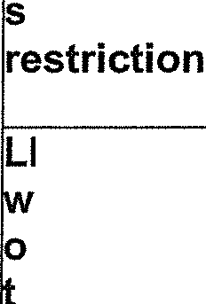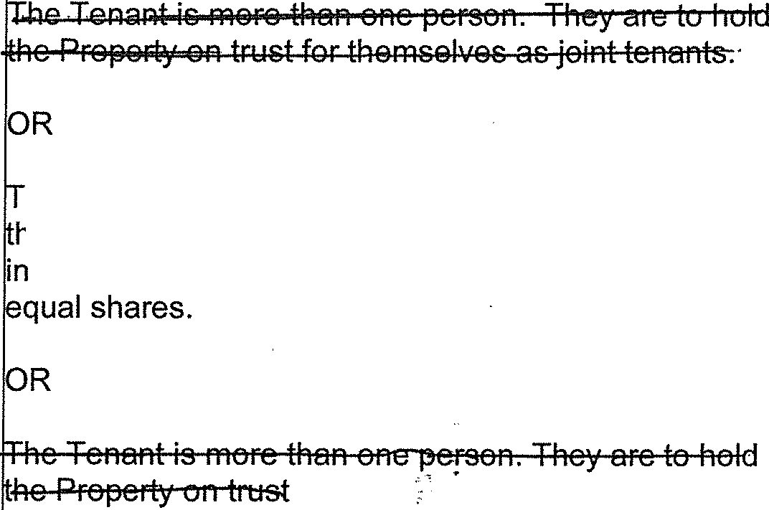I I I I I I I I I I I I I I I I I I I



i

|  |
| --- |
| **asements grantea or reservea 1:>y tllis lease**  **!over the Property for the benefit of other property**  s set out in Clause 3 of this Lease and Part 3 of the chedule of the Existing Lease |
| **LR12. Estate rentcharge** !None  **burdening the Property** |
| **LR13. Application for** !None  **tandard form of** |
| **LR14. Declaration of trust here there is more than ne person comprising he Tenant**  he Tenant is more than one person. They are to hold  he Property on trust for themselves as tenants in common1 |

I 3

**THIS LEASE** is made on the date stated in the Prescribed Clauses.

#### BETWEEN:

1. The Landlord referred to in Paragraph LR3 of the Prescribed Clauses.
2. The Tenant referred to in Paragraph LR3 of the Prescribed Clauses.

**NOW THIS DEED WITNESSETH** as follows:-

#### DEFINITIONS AND JNTERPRl;JATION

1. In this Lease: -
   1. "the Landlord" includes the successors in title of tt:le Landlord.
   2. "the Tenant" includes the successors in title of the Tenant.
   3. "the Property" means the premises referred to in Paragraph LR4 of the Particulars as more particularly described in the Existing Lease
   4. "the Existing Lease" means the Lease dated 16 October 1997 of the Property made between (1) Sinclair Gardens Investments (Kensington) Limited and (2) Anthony James Occleshaw which is registered at the Land Registry under Title Number AGL60759
   5. "the Existing Term" means the term of years granted by the Existing Lease.
   6. "the Act" means the Leasehold Reform, Housing and Urban Development Act 1993 (as amended).
   7. "the Rent" means a peppercorn (if demanded).
   8. The words and expressions defined in the first column of the Prescribed Clauses have the meanings opposite them in the second column of the Prescribeq, Clauses and shall for all purposes of this Lease have the meanings therein specified and the words

4

# I

I

and expressions defined in this Clause 1 shall for all purposes of this Lease have the meanings therein specified.

I 1.9 Words importing one gender include all other genders and words importing

the singular include the plural and vice versa.

I

* 1. O Whenever any party to this Lease shall comprise more than one person the covenants and obligations on the part of that party in this Lease shall be construed as being the joint and several covenants and obligations of that party.

I

I

* 1. Unless otherwise stated references to the Property include each and every

part of the Property.

* 1. The details, expressions and descriptions appearing in the Particulars shall be included in and form part of this Lease..
  2. The headings in this Lease are for information only and shall not be taken to form part of this Lease or affect the construction of it.
  3. "the Building" means the building of which the Property forms part and is more particularly described in the Existing Lease

1. **RECITALS**
   1. The Tenant in exercise of the rights conferred on the Tenant by the Act has requested the Landlord to grant the Tenant a lease of the Property for an extended term under the Act in substitution for the Existing Term and the Landlord has agreed to do so on the terms hereinafter appearing.
   2. The Property is vested in the Tenant whose.title thereto,is

.I

registered at the Land Registry under the Tenant's Title Number for all the unexpired residue of the Existing Term subject to the rent reserved by the Existing Lease and to the tenant's covenants and conditions contained in the Existing Lease.

* 1. The reversion immediately expectant on the Existing Term is vested in

the Landlord whose title is registered at the Land Registry under the Landlord's Title Number.

#### DEMISE

IN consideration of the Premium paid to the Landlord by the Tenant {the receipt whereof the Landlord hereby acknowledges) and of the covenants hereinafter contained the Landlord HEREBY DEMISES unto the Tenant with limited title guarantee ALL THAT Property together with the benefit of the rights granted in the Existing Lease and subject to the same exceptions and reservations as are expressed in the Existing Lease TO HOLD the Property for the Term subject to and with the benefit of the tenant's and the landlord's covenants respectively contained in the Existing Lease, the provisos agreements declarations stipulations and conditions contained in the Existing Lease and all rights easements quasi easements privileges covenants restrictions and stipulations affecting the Property YIELDING AND PAYING to the Landlord the Rent {as defir:ied by this lease) and all other monies payable as rent under the Existing Lease on the days and in the manner contained in the Existing Lease EXCEPTING AND RESERVING unto the person who is for the time being the Tenant's immediate landlord the right to obtain possession of the Property pursuant to Section 61 of the Act in accordance with Clause 6.2 hereof.

#### INCORPORATION OFTERMS QF EXISTING LEASE

Except as expressly provided in or otherwise inconsistent with this Lease this Lease incorporates and is made upon the same terms and subject to the same conditions covenants stipulations provisos agreements and declarations in all respects as those contained in the Existing Lease as if they were repeated in full in this Lease

#### COVENANTS

The Landlord and the Tenant respectively covenant with the same *party* or parties as they so covenanted in the Existing Lease (as if the names of the Landlord and Tenant parties hereto had been respectively substituted for those of the Landlord and Tenant in the Existing Lease) that they will respectively perform and observe all of the covenants

conditions stipulations provisos agreements and declarations on their part referted to in Clauses 3 and 4 hereof and be bound by the other provisions of the Existing Lease which are incorporated into this Lease by virtue of Clause 4.

I

#### AGREEMENTS AND DECLARATIONS

It is hereby agreed and declared that:-

* 1. No long lease created immediately or derivatively by way of sub-demise under the term hereby granted shall confer on the sub-tenant as against the Landlord any right under Chapter II of Part I of the Act to acquire a new lease (and for this purpose "long lease" shall be construed in accordance with Section 7 of the Act).
  2. The Landlord may (a) at any time during the period of 12 months ending on the last day of the Existing Term and (b) at any time during the period of 5 years ending on the last day of the Term of this lease apply to the Court under Section 61 of the Act for an order for possession of the Property on the ground that for the purpose of redevelopment it intends to demolish or reconstruct or to carry out substantial works of construction on the whole or a substantial part of the Building and that it could not . reasonably do so without obtaining possession of the Property and the provisions of Section 61 apd Schedule 14 of the Act shall apply accordingly.
  3. The Landlord shall not be personally liable under any of the covenants on its part herein contained otherwise than in respect of -breaches thereof for which it is responsible.

Existing Lease.

This Lease is granted under Section 56 of the Act in substitution for the

#### MISCELLANEOUS

* 1. The conditions for re-entry in the Existing Lease which are incorporated into this Lease by virtue of Clause 4 hereof shall be exercisable as well on any breach of the covenants and conditions herein as on the happening of any of the events mentioned in such conditions for re-entry.

7

* 1. As soon as reasonably practical after completion of this Lease, the

Tenant shall register this Lease and all rights granted or reserved under this Lease at the Land Registry.

* 1. This Lease is a new lease for the purposes of the Landlord and Tenant (Covenants) Act 1995.
  2. This Lease embodies the entire understanding of the parties relating to the provisions of this Lease.

IN WITNESS thereof the parties hereto have hereunto executed this document as their Deed the day and year first before written.

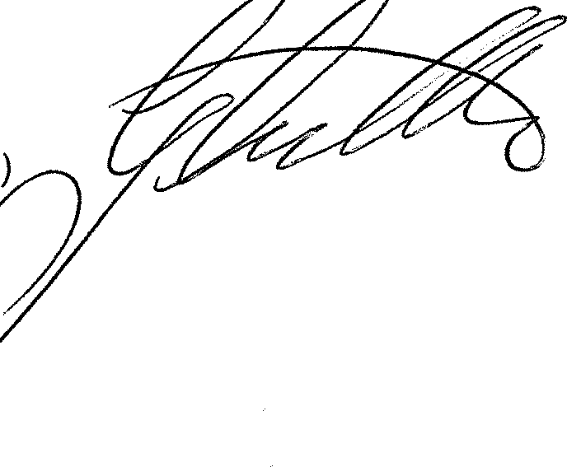EXECUTED as a Deed and delivered on the day ) and year first above written by **Sinclair Gardens** )

**Investments (Kensington) Limited** acting by a Director, Greg Cutler, in the presence of

Signature ,,

Name 8

Address Regis House

Regis 6usine1;;s Centre

Durban Road Bognor Regis West Sussex

J:,crr

._,..,??

8

I

### I

I

SIGNED as a Deed by **Maria Theresa John**

In the presence of Witness Signature Witness Name Witness Address

Witness Occupation

SIGNED as a Deed by **Vincent Lewis John**

In the presence of Witness Signature Witness Name Witness Address

Witness Occupation

9